**MICROWAVE OVEN**

**INTRODUCTION:**

Commercially available microwave oven systems lack in functionality and user friendliness. Despite the obvious advantages, the microwave ovens can be improved to fit everybody's cooking need. There are strong incentives to reduce costs while increasing the speed, functionality, accuracy and flexibility of the microwave systems.

**BLOCK DAIGRAM:**

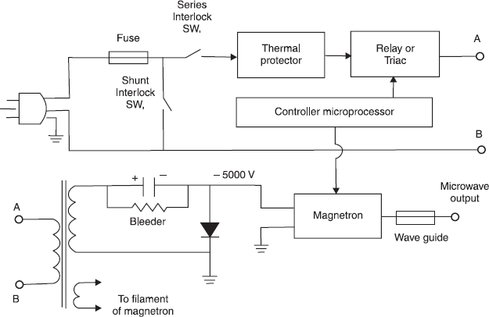

**WORKING PRINCIPLE:**

Microwave ovens work on the principle of conversion of electromagnetic energy into thermal energy. Electromagnetic (EM) energy refers to the radiation (waves) comprising an electrical field and magnetic field oscillating perpendicular to each other. When a polar molecule, i.e., a molecule containing opposite charges, falls in the path of these EM radiations, it oscillates to align with them. This causes the energy to be lost from the dipole by molecular friction and collision, resulting in heating. The water molecules present inside our food products go under a similar phenomenon when they come in contact with microwave radiations, heating the food from inside out. Microwaves are electromagnetic radiations with frequencies between 300MHz (0.3 GHz) and 300 GHz, and the corresponding wavelengths ranging from 0.9m to .0009m, respectively. In most of the ovens, the microwave used is of 2.24GHz frequency (i.e., wavelength = 12.2cm). These dimensions allow microwaves to penetrate deep inside the food and cook it from inside, while the temperature of the air present around the food remains constant as air is nonpolar. There is a common misconception that microwaves in a microwave oven excite a natural resonance in water. The frequency of a microwave oven is well below any natural resonance in an isolated water molecule, and in liquid water, those resonances are so smeared out that they’re barely noticeable anyway.

**MAIN COMPONENTS:**

**High Voltage Transformer:**

Unlike many other household appliances, the microwave oven requires more power than the normal voltage that the home’s electrical wiring carries. To accomplish this, a step-up transformer with a high-voltage output is placed inside the oven. The 240V supply is jumped to a few thousand volts, which is then fed to the cavity magnetron.

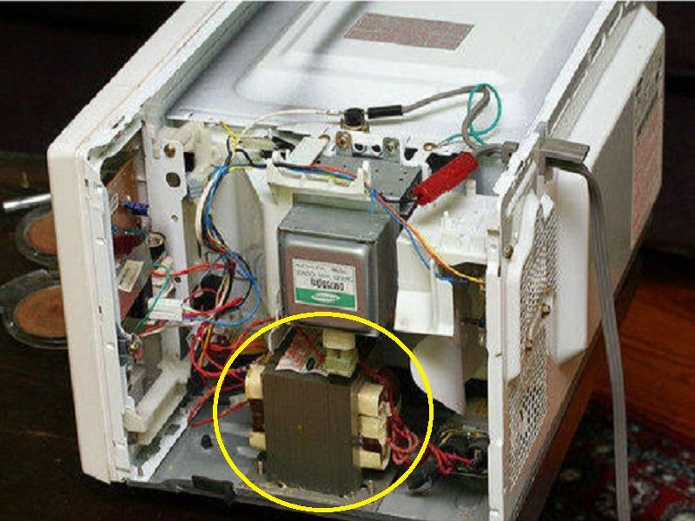

**CAVITY MAGNETRON:**

A cavity magnetron is a high-powered vacuum tube that transforms the electrical energy into long-range microwave radiations, and hence it is the most important component of a microwave oven.

**MICRO CONTROLLER:**

A microcontroller is something that enables communication between a user and a machine. It is a controlling unit that contains one or more processing cores along with memory and programmable input/output peripherals. It processes the instructions that a user gives to the microwave oven and also displays them on a seven-segment display or a LED screen, depending on the model of the oven.

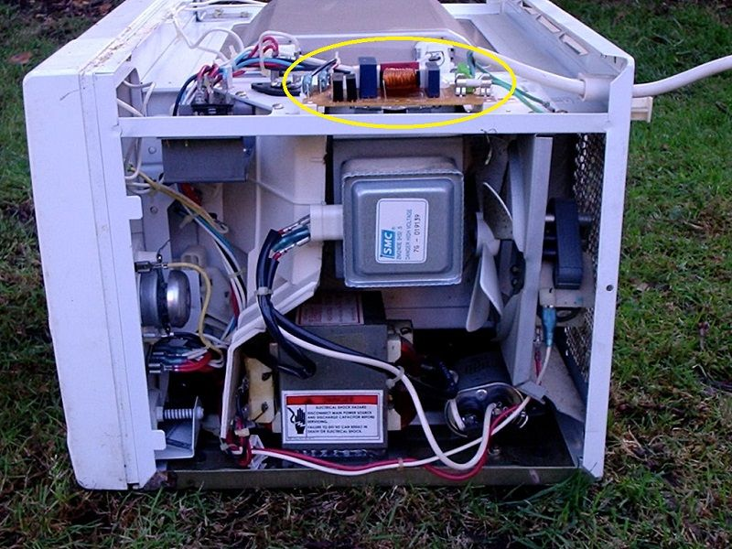

**WAVE GUIDE**:

As the name suggests, a waveguide is a hollow metallic tube that guides the waves generated at the magnetron’s output toward the cavity (the place where we place the food).

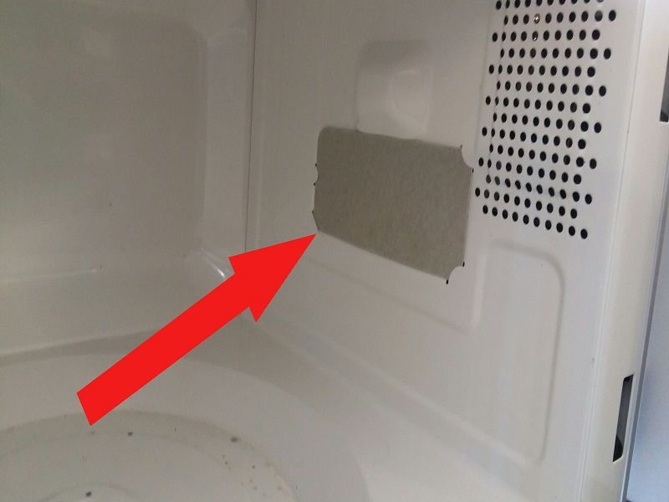

**COOLING FAN:**

Cooling fans reduce the magnetron’s operating temperature and ensure its efficacy and longevity.

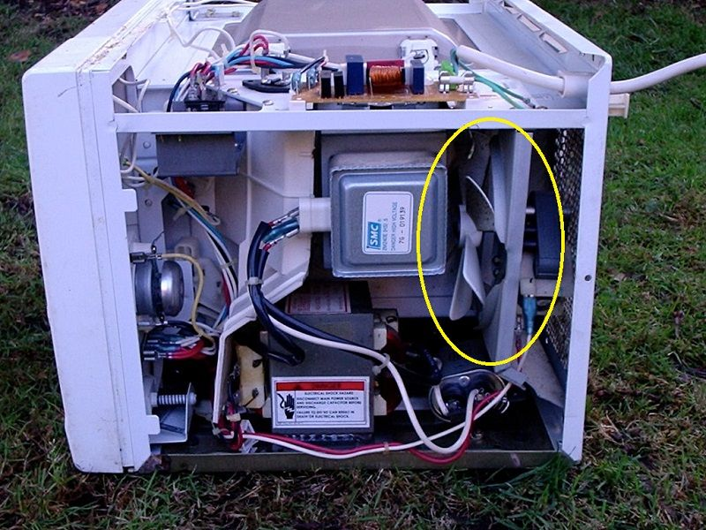

**WORKING MECHANISM:**

The process of heating food in the microwave oven is fairly simple; however, the mechanism involved in that process is somewhat atypical. After the generation of microwaves at the magnetron, they are guided by the waveguide towards the food inside the cavity. The microwaves penetrate through the surface of the food and reach the water molecules present inside it. As the orientation of the electric field changes over time, the polar molecules of water attempt to follow the field by changing their orientation inside the material to line up along the field lines in an energetically favourable configuration (namely, with the positive side pointing in the same direction as the field lines). As these molecules change direction rapidly (millions of times per second at least), they gain energy, which increases the temperature of the material. This process is called dielectric heating. The microwave energy diminishes according to the inverse square law, and therefore, the cavity chamber, where we place food, is designed in such a way that it carries out the maximum efficiency of the heating effect of microwaves. Furthermore, most of the microwave ovens come with a door switch that does not allow the process to initiate until the door is completely sealed.

**ADVANTAGES:**

* The volumetric heating process of microwaves is their most prominent characteristic. In the conventional cooking method, the heat must spread inwards from the surface of the food item, whereas the spread of heat in the case of microwave oven is done in a controlled manner with the help of the microwaves.
* It’s a quick and convenient method of heating food and leftovers.
* Since microwaves can only interact with polar substances like water, they cannot affect the nutritional value of those ingredients that are non-polar. Other conventional cooking methods, however, may destroy some polar as well as non-polar ingredients during the process.
* The user interface and micro-controller facilitate precise control over the cooking temperature.
* The ease of the cooking process in a microwave oven also results in easier cleaning of the equipment after use.

**DISADVANTAGES:**

* It is important to take care of what kind of utensils are being used in a microwave. A dish that is not microwave-safe will set off a chemical reaction between the food and the container.
* The cost of equipment is high in comparison to other conventional cooking methods.
* Microwave leakage may lead to electromagnetic interference with other electrical equipment present in the surrounding vicinity. The pacemakers installed in some patients are particularly vulnerable to such radiation leakage.
* Microwave radiation can heat body tissue the same way it heats food. Exposure to high levels of microwaves can cause a painful burn. In particular, the eyes and the testes are vulnerable to microwave heating because there is relatively little blood flow in them to carry away excess heat.
* Another disadvantage of microwaves is that they have limited capacity and because of this, they are not the best option for large families.